**CHAPTER I**

**INTRODUCTION**

This chapter begins with an introduction to the problem that the project aims to solve, as well as general information about the project's objectives and goals.

**Background of the Study**

The study focuses on evaluating the usability and user experience of the Period prototype, an innovative app that changes the system by upgrading feminine product vending machines into authentication-based storage boxes. With features that can locate PQs, scan QR codes, earn daily points for authentication consumption, make friends with other users, and buy points, this study aims to gather user feedback on the app’s usability, functionality, its design, and overall user satisfaction. By employing a one-on-one interview with potential users, the research seeks to understand their suggestions, recommendations, satisfaction, and any challenges encountered, thereby encapsulating it to improve our application and hardware counterpart that meet users wants and needs.

**Solving the Problem**

With Period, we devise a plan to change vending machine-selling sanitary products into Authorization-based storage boxes. Rather than using a 10 pesos coin to exchange pads, we created an app that only needs your fingerprint, and of course, data connection, to access the compartment. By analyzing real-world experiences of people who undergo menstruation, we can opt to create the software and hardware that will not only attract users through design, but also attract them to the features it offers. This iterative process ensures that Period evolves in alignment with user expectations and preferences. In time, our goal is to reframe feminine product vending machines into a more inclusive and less paywall service, thereby improving overall user satisfaction and daily living.

***Who are the potential users?***

When it comes to Period, the potential users would include a diverse range of individuals that experience the life of having period pains while currently at a public background. This includes women who have transitioned into men who are still undergoing their period, girls that are currently arriving at the stage of puberty, and women that hopes for a better more efficient way to save their period days.

***What tasks do they seek to perform?***

Potential users can expect Period to perform tasks that will make their lives a bit easier when it comes to getting feminine products. Period has a built-in locating device that will locate nearby storage boxes, mostly known as Project: Quality (PQs), to help users to identify if there are nearby PQs on their area. Users can also expect befriending other users, in which you can request points or give out points towards them. Speaking of points, these are used as a form of currency when authenticating PQs, which are regenerating 10 or 60 points based on users who are currently on their period or not, to stop users on abusing the free supply system. Points can also be bought at the store. Lastly, Users can expect to see their daily activities in their profile to remind them of their past purchases and tasks.

***What functionality should any system provide to these users?***

These users should be provided an easier way to access feminine care sanitary products. So, when comes to Period, authentication through fingerprint is used to access the storage boxes, storing all kinds of sanitary products. The removal of paywalls from feminine care is a wonderful functionality that must be provided at no cost.

***What constraints will be placed on your eventual design?***

As Period comes into the limelight, there would be constraints when it comes to its hardware. Storage boxes will have limited sanitary products stored in them, and if the ratio of users nearby the PQ are currently higher than the products within the PQ, there would be transaction problems.

***What criteria should be used to judge if your design is a success or not?***

The success of Period would be based on the users’ satisfaction, measured through feedback on their overall experience. Engaging users through frequent and sustained app usage will indicate its effectiveness in meeting their needs. Reliable performance across various devices and platforms, coupled with minimal technical issues, ensures a seamless user experience. Additionally, adherence to stringent data security standards and strong market adoption underscore the app's relevance and trustworthiness in the marketplace.

**Statement of the Problem**

Our project, Period, will tackle the following problems:

1. **Paywall For Relief:** When it comes to getting sanitary napkins and tampons, users are pressured to use their coins to obtain their desired item.
2. **Outdated Machinery:** Usually, when using feminine product vending machines, coins get clogged or does not register brand new coins.

**CHAPTER II**

**RESEARCH DESIGN**

The following chapter contains an analysis of the project’s requirements according to its objectives in order to map out the focus of the prototype.

**Task Analysis**

**Hierarchical Task Analysis:**

1. Purchasing Items Through Authentication
2. Locate Nearby PQ
3. Scanning QR
4. Receiving Daily Points
5. Giving Points to Users
6. Requesting Points to Users
7. Purchasing Points

**Requirements Gathering**

Requirements gathering involves collecting and documenting the necessary information for designing the application.

**Method Used:**

* **Interview:** Conducted interviews with potential users to understand their input on turning feminine care products for free when it comes to menstrual cycle.

**Requirements Based on Perspectives:**

* **User Requirements:**
  + The system should allow users to obtain sanitary napkins conveniently.
  + Users should be able to access the service discreetly and without embarrassment.
  + Process of obtaining sanitary napkins and tampons should be quick and efficient.
* **Functional Requirements:**
  + System should notify administrators when stock levels are low.
  + Authentication through app is a needed mechanism to verify authenticity of users to get free sanitary napkins.
* **Data Requirements:**
  + Collect user data for eligibility verification.
  + Ensure data privacy and security.
  + Maintain an inventory database with information on available sanitary napkins.
* **Environmental Requirements:**
  + Minimize waste; Encourage users for proper disposal of used napkins.
  + Consider the carbon footprint of distribution methods.
  + Use eco-friendly materials for the storage boxes.
* **Usability Requirements:**
  + The user interface should be intuitive and easy to navigate.
  + The system should be available 24/7 for emergency situations,
  + Accessibility features, such as multilingual support, audio instructions, etc., should be considered.
* **Designer Requirements:**
  + Design the app interface with a clean, modern aesthetic.
  + Use colors and visuals that resonate with the target audience.
  + Consider incorporating elements related to femininity, empowerment, and hygiene.

**CHAPTER III**

**DESIGN PROCESS AND PROTOTYPING**

The following chapter illustrates the project’s design choices and summary, showcasing the evolution of the application. This chapter also contains the official prototype of the application.

**Design Space**

Period is a compassionate and forward-thinking initiative aimed at revolutionizing access to sanitary napkins for women. Its logo is a powerful representation of our mission. The symbolism towards femininity, strength, and inclusivity. The color palette, typography, and message contribute to its symbolism towards the logo.

**Design Summary**

Our designs lack in the initial process (sketching, storyboarding), however we thought of a design that will have an impact towards our selected users.

**Application Icon**

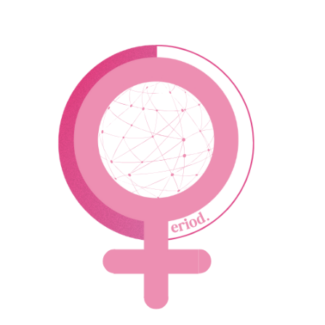

**Design**

The Period application wants to appeal to the users through a comfortable design. So, to showcase the design, we have to identify what the Color Palette, Font Style, and GUI is.

**Color Palettes**

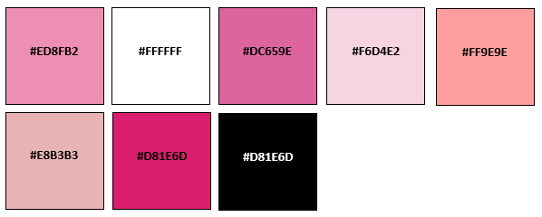

The chosen color palette is the main colors that would be seen in our application. We have chosen this color palette to promote femininity and the hues of pink usually signifies calm and peace.

**Prototype**

* **GUI**

The pair has decided to use an Android GUI to showcase the aforementioned GUI, yet a hypothetical IOS GUI will be at least similar. This GUI isn’t functionable as of now since this is more like a sample. The GUI showcased below might change in the future.

 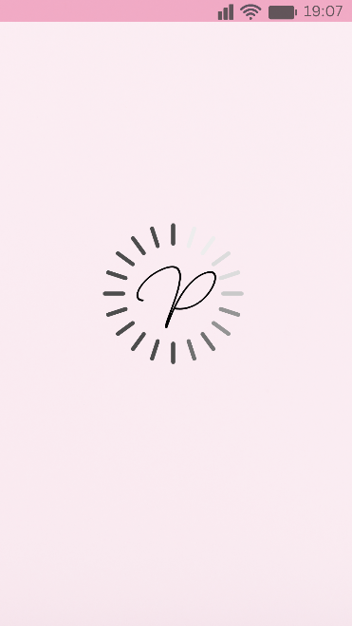 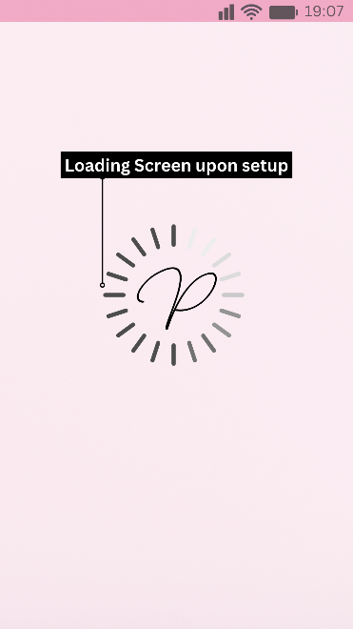

**Loading Screen –** This what will happen when you open up the app to let you know the app is initializing.

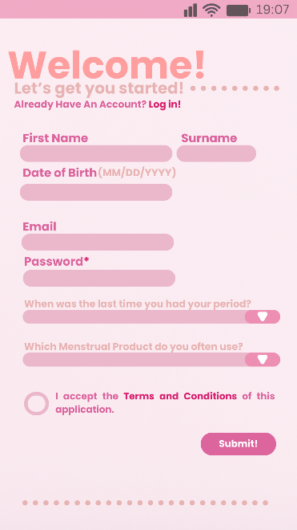 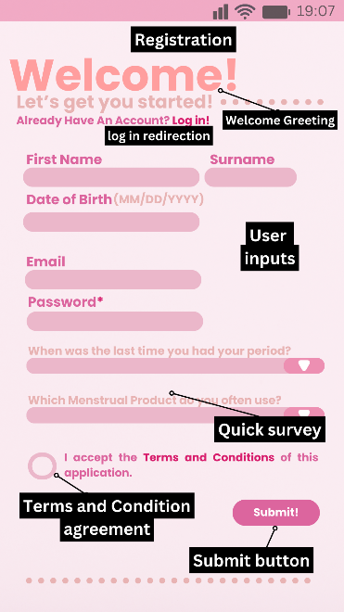

**Registration –** This shows how the registration work. A simple user inputs and agreeing to the terms and condition, which will then proceed to the promotion screen.

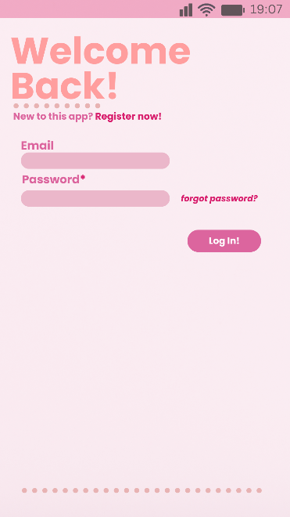 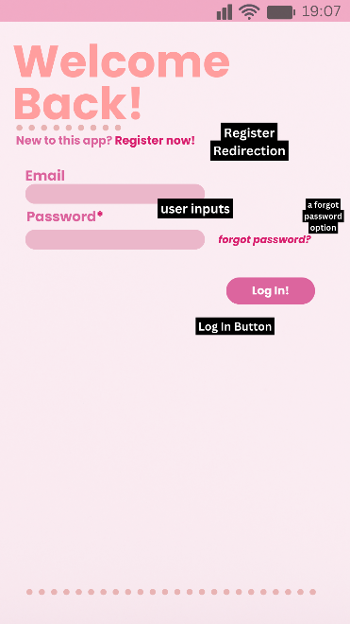

**Log In –** This displays the log in when you press the log in redirection and vice versa when clicking the “register now!”. Just as the registration screen, but you input the authorization inputs instead of your name, birthday, and doing the survey.

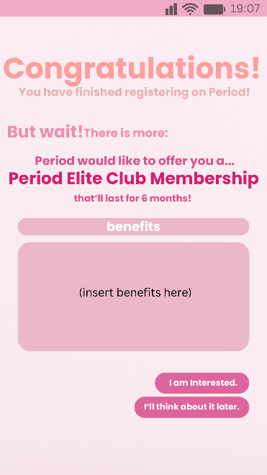 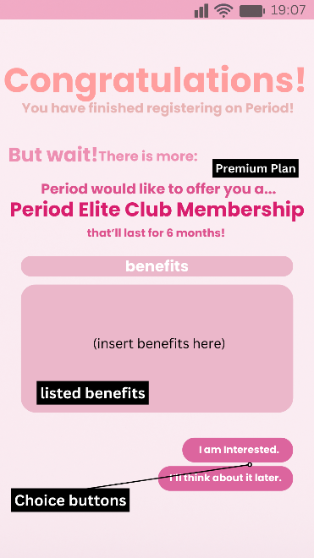

**Promotion Screen –** After registering, you will be redirected to an offer. This where you can accept or not accept the offer. If you chose “I am interested”, you will be redirected to the **shop.** However, pressing “I’ll think about it later” redirects you to **home.**

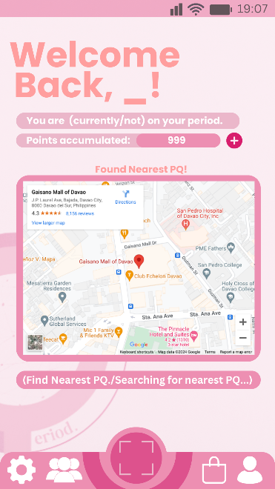 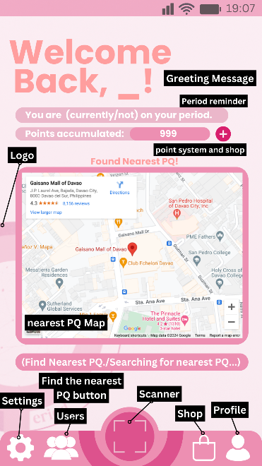

**Default Setup / Home –** Here will display your status and points. You’re able to find the nearest-installed PQ (Vending Machine). You can press the icons below to redirect you to that location.

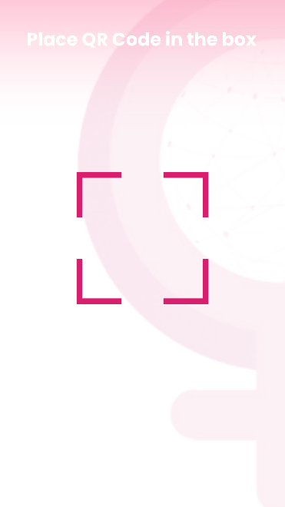 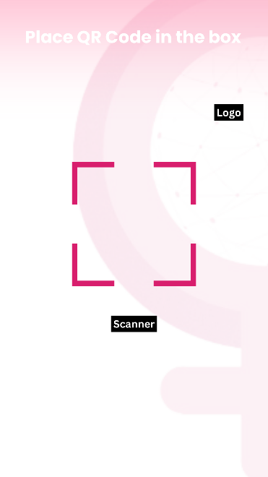

**The QR function –** When pressing the **scanner**, you are redirected to this screen where you are able to place a PQ QR code. This scanner can only identify PQs and is invalid if scanned to a non-PQ QR.

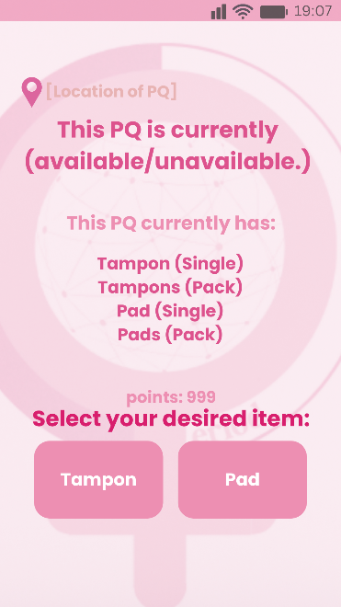 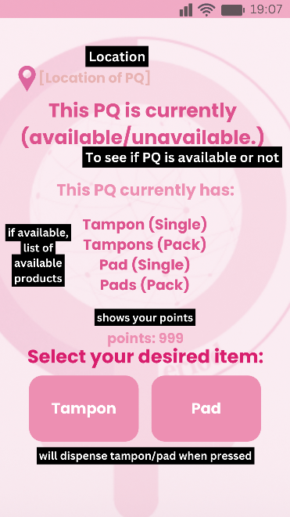

**Authentication for PQ –** After scanning a PQ QR, you will be redirected to this screen where it’ll display the location, the status, and the available items in the PQ. After that, you can see at the bottom where you can pick either tampon or pad to dispense. Using PQ requires 10-30 points and you can gain them daily (60 pts.).

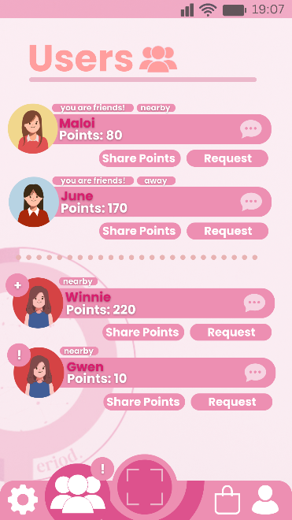 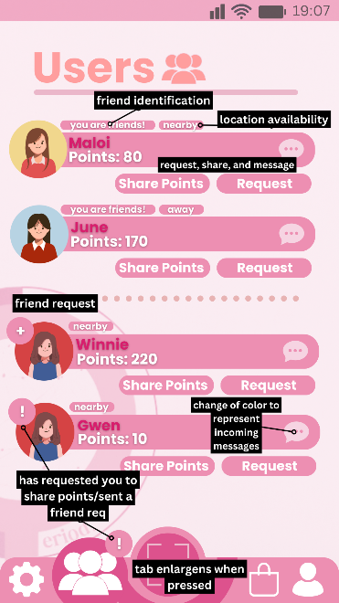

**Users –** In Period, there is an option to befriend other Period users. The users displayed will have their name, points, and their location status. Here you can share and request points with other users.

**Store –** This tab in Period displays the Premium membership and an option to inquire a PQ in your establishment. Below, shows points you can buy so you can use PQ.

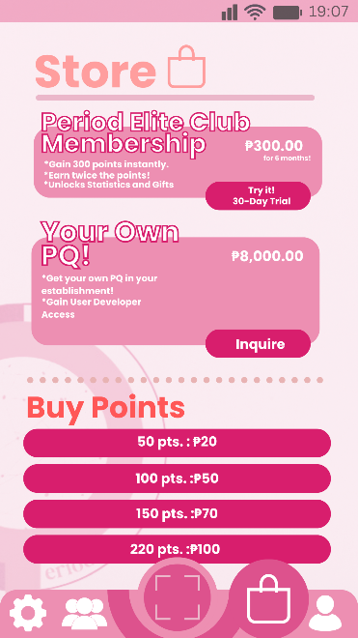 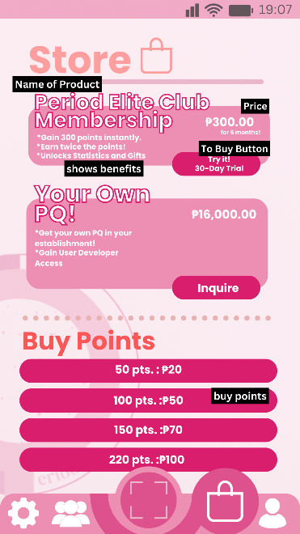

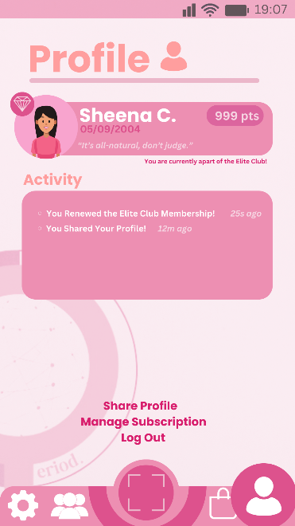 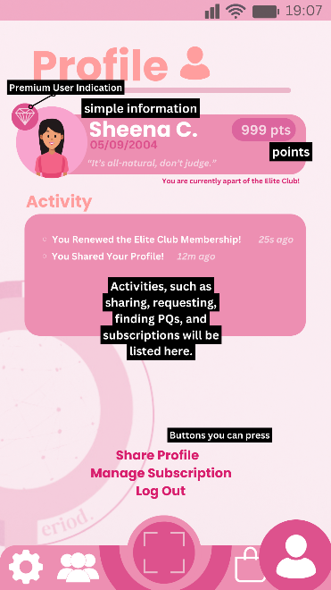

**Profile –** This where your profile shows. This displays your name, your birthdate, points, and activities. Here you can share your profile, manage your subscription, and log out.

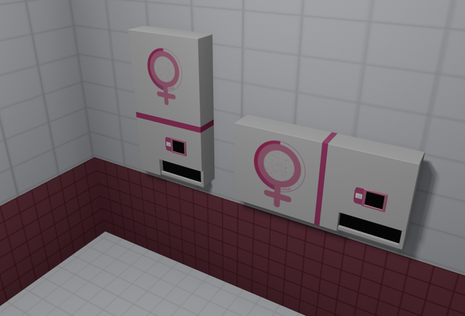

**PQ –** PQ stands for “Project: Quality” where the vending machine that dispenses tampons and pads require authorization instead of coins.

**Design Alternatives**



** **

**Supposed App Logos** – The app logo would’ve been different from the actual Period logo, but all of them were scrapped due to being too different from the overall design. Instead, we used the same typeface P to be the logo for the loading setup.

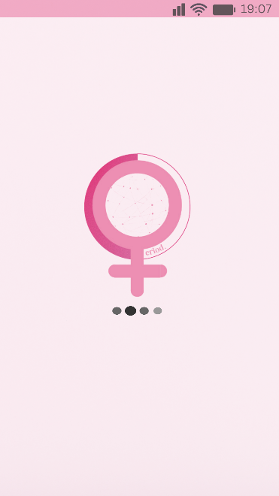 

**Logo On Loading Screen** – Supposedly, the Period logo was going to be the center, however it was scrapped because it didn’t capture a minimalistic look for the loading screen.

**CHAPTER IV**

**EVALUATION OF PROTOTYPING**

This chapter contains the evaluation of the prototype and the results and feedback of future users.

**Evaluation Plan**

The application’s prototype will be judged on the following questions to gauge the users’ feedback on the aesthetic and the ease of use:

1. Are you satisfied with the aforementioned information?
2. Is there anything you would like to add?
3. Is there anything you would like to remove?
4. To end this survey, please briefly describe what services Period has to offer.

**Results**

**Participant Survey and Feedback**

 

 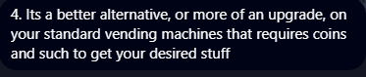



**Discussion**

The data we’ve collected represents the success we’ve made from our product. It no longer needs any adjustments and if published to the public, might have satisfied users.

.

**CHAPTER V**

**Summary**

So, to summarize our application, Period, it ensures equitable access to free sanitary napkins for women through upgrading feminine product vending machines into authentication-based storage boxes. Our user-centric system offers discreet distribution through apps or kiosks, prioritizes sustainability, aims to empower women, foster community, and redefine menstrual hygiene.

**Conclusion**

After an extensive design process, the Period initiative has received positive feedback from its prospective users. While there remain areas for improvement, we recognize the potential for growth. Despite these minor gaps, the prototype demonstrates immense promise in reshaping menstrual hygiene access. Together, we’re making a lasting impact.